8
Chapter

Bridge Analysis

Introduction
The purpose of the bridge analysis package is to facilitate structural analysis of bridges in terms of a bridge and its components. At an abstract level application developers using the Washington Bridge Foundation Libraries do not care about the exact method of structural analysis used to analyze a bridge model so long as the analysis is reasonably quick and the results are correct and accessible. The application developer need not get bogged down in the details of a particular structural analysis technique, such as tracking the relationship between nodes and elements in a finite element model to connections and spans in a bridge product model. The Bridge Analysis package is an insulating and adaptive wrapper over a specific structural analysis method.
The scope of this incarnation of the BAM is to model a two-dimensional, single girder line approximation of a bridge. This makes use of the so-called “strip” methods outlined in the LRFD/LFD specifications. Concepts such as live load distribution factors and equivalent sections are used to collapse the width dimension of the bridge deck in order to create a wire frame or beam model. This concept is commonly used by bridge engineers to analyze simple bridge types. Later BAMS will be developed to model 3D girder line models and perhaps even more complex analysis models.
Although the BAM is not a product model of a bridge, it should provide as much of a “bridge-like” interface as possible to clients. This will make it easier for clients to understand and work with the BAM classes.
Although the BAM could potentially be implemented as a single class, it should use the concept of interface inheritance to separate out it’s unique interfaces. The major types of interface that the BAM should support are as follows:
- Analysis model description and editing
- Load application and editing
- Response request and editing (POI’s)
- Results retrieval
- Data storage
The reasons for separation of these interfaces may not seem obvious at first. Especially because the BAM state due to one set of interface requests will be dependent on the state made from the requests of another interface (e.g., it is bad form to load a span that doesn’t exist). However, clients of the BAM will likely often be interested in only a single BAM interface and not the entire system (“I asked for a banana and got the whole gorilla”). Use of pure interfaces will also facilitate the use of proxy patterns and other powerful tricks.
I would like to reiterate that, although they are separated physically, these interface classes are very much logically interdependent. Figure 1 outlines these dependencies:
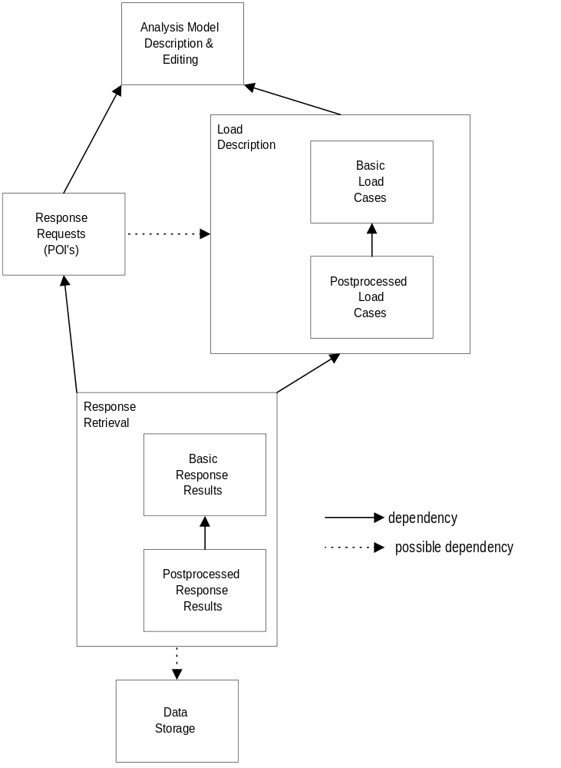
Figure 1

Purpose
The purpose of the BAM is to calculate forces and deflections due to loadings and combined loads on an analysis model of a bridge structure. The BAM does not calculate stresses.
The BAM interface shall be specification independent. This specification independence can be achieved by providing a generic superset of all foreseeable specifications to be used by BAM clients. BAM internals, such as the LiveLoadSolver may be forced to be spec dependent. However, this dependence should be avoided at all reasonable costs.

Potential Clients
Probably the most difficult requirement for the BAM is that it must provide a flexible enough interface to satisfy response requests from many, diverse clients. The following is a list of clients expected to modify and request data from the BAM system.

The BAM itself (e.g., load combos)

Input

GUI

Model builders

File Persistence

Reports

High-Level User Reports

Dump Files
All BAM classes should provide a Dump(std::ostream&) function that dumps out all internal details.

Graphs

Specification Engines

OLE Containers?

Functional Requirements
The Bridge Analysis package must satisfy the following requirements:

Encapsulation of Analysis Engine
The implementation of the core analysis engine should not be apparent to the client. In other words, we should be able to change structural analysis techniques while maintaining the public interface.
This will be accomplished by providing an interface to the analysis model which uses the terminology of the bridge domain. This means that clients should not be subjected to referring to element numbers, cryptic load case schemes and other such nonsense that really has nothing to do with the analysis of a bridge.

Staging
Time dependent effects on responses must be addressed by the BAM. Staging can affect the BAM in the following ways:
- Model geometry and stiffness changes (support locations may not change).
- Support fixity and span end condition changes (SDCL)
- Addition/Removal of loadings through time.
- Addition/Removal of POI’s through time?

Analysis Model Description and Editing
The Bridge Analysis package must support the editing and modeling of the following bridge analysis component types:

The Bridge
One way to look at a bridge is to consider it to be a composition/assembly of its parts. The bridge provides rules as to what parts it can be made of and how the parts are assembled together. The bridge model for the BAM is very simple; it is composed of Span Elements and Support Elements.
Dealing with whole-part relationships is complex. It is not the place for a requirements document to determine if bridge parts should be entirely encapsulated by the bridge, or if the bridge should act only as a ‘smart container’ for its parts.
The bridge has the following capabilities
- Create/Add a Support
- Delete a Support
- Get the number of supports
- Iterate through the Supports (const & non-const)
- Create/Add a Span
- Delete a Span
- Iterate though the Spans (const & non-const)
- Get the total Bridge Length

Supports
Supports have the following information and behaviors associated with them:
- Create Support at X location
- Move Support to another X location
- Get Left/Right connected Span
- Set/Get Fixity

Span Elements
Spans have the following information and behaviors associated with them:
- Set/Get Support at left/right end
- Set/Get/Enumerate/Iterate through/Modify stepped section properties (Area, Iz, Density, E, live load distribution factors for shear, moment and deflection) along length.
- Add/Move/Remove Hinges Within Spans or at Span ends.
- Set/Get/Modify Overhangs at span ends
- Get Span total length

Communication Between the Bridge and Its Parts
It is desirable to decouple the bridge itself as much as possible from the types of the parts it is composed of. This will facilitate the introduction of new span and support types into the bridge at a later date. It is also desirable to decouple the parts from the type of bridge they are assembled into. Two basic patterns come to mind that can do this: Mediator and Observer.

Mediator is typically used in whole-part relationships where the interaction between the whole and its parts is well-defined, and changes in parts are likely to affect other parts in the system using rules defined outside of the parts themselves.

Observer is better used in the situation where the relationships are generally unknown and changes are likely to take affect from the bottom-up in the whole-part hierarchy.

The Mediator pattern seems to be a good fit for a bridge since the bridge controls interaction between the parts and it is desirable to be able to access and edit the parts individually. Below are messages that parts of the bridge would send to the bridge:

Message | Data Sent | Notes
Support Elements:
Move | self | Bridge can veto
Change Fixity | self
Span Elements:
Change Overhang | self | Bridge can veto
Add Hinge | self | Bridge can veto
Modify hinge | self | Bridge can veto
Change Section Props | self

Load Appication
The Bridge Analysis package must satisfy the following requirements for loading

Orientations
The basic loads can have one of the following orientations, Local, Global, or Global Projected.

Basic Loading Cases
Basic load cases are generally composed of raw, unprocessed static loads such as those that can be solved directly by a simple finite element engine. For each of the load cases listed in the following sections, an unlimited number of the the following load types must be supported.
- Concentrated forces Fx, Fy, Mz and,
- Linearly distributed forces Wx, Wy, Mz or,
- Enforced displacements Dx, Dy

Self Weight
Concentrated and distributed loads.
Self weight loads maybe applied externally or calculated from the bridge analysis model.

Added Dead Load (utilities)
Concentrated and distributed loads

Overlays
Concentrated and distributed loads

Sidewalks
Concentrated and distributed loads

Interior and Exterior Diaphragms
Concentrated and distributed loads

Parapets
Concentrated and distributed loads

Foundation Settlement
Enforced displacements at supports

User-Defined Loads
An unlimited number of named, user-defined load cases can be added to the system. User-defined loads may be applied to any part of the analysis model.
User defined loads can consist of concentrated and distributed loads or support settlements. Forces and displacements may not be applied in the same load case?

Influence Lines
The BAM must be able to calculate influence lines for all Poi’s and supports in a model. Influence lines must be available for all applicable force effects (even deflections?).
Influence line calculation is expensive. A mechanism should be put in place to make calculation of influence lines optional.
Specification of stepping locations for influence line generation may be specified directly by the client or determined by a default method. Step increments need not be uniform across the bridge or across spans.

Postprocessed Load types
Postprocessed load cases are those load cases that can be determined solely from the results of basic load cases. Hence, these load cases are not necessarily dependent on the analysis engine used by the BAM.

Live Load Models
A live load model consists of groups of truck/lane combinations with attributes as shown in Figure 2.
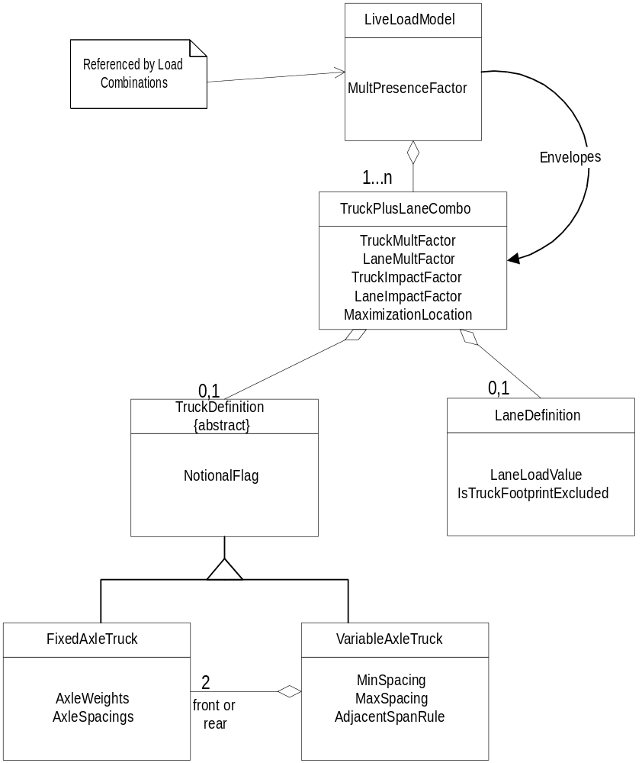
Figure 2
Figure 2 indicates that a LiveLoadModel is the top-most definition. A LiveLoadModel can envelope over one or many TruckPlusLaneCombos. Each TruckPlusLaneCombo contains one TruckDefinition and one LaneDefinition. A TruckDefinition can be either a single FixedAxleTruck or a VariableAxleTruck which can have variable axle spacing between one of its two fixed axle sets.

For example, the Design Vehicular Live Load as defined in LRFD 3.6.1.3 would consist of up to four TruckPlusLaneCombos: 1) The design tandem plus the design lane load, 2) The variable-axle design truck plus the design lane load, 3) For reactions and negative moment between contraflexure points, 90% of two variably-spaced, fixed-axle design trucks plus 90% of the design lane load, and 4) two variably-spaced fixed axle tandems plus the design lane load.

Axle position at location (could be a Basic load case)
Responses may be calculated due to a set of axle loads placed anywhere along the length of the superstructure. Response calculation for both notional and non-notional trucks.
These calculations could be supported by two versions of the interface(s): a high-performance version and a complete version. The high-performance version could be tuned to calculate response for only one degree of freedom for a given response location. This would provide fast response for live loading algorithms. The full version would provide results for all degrees of freedom so that corresponding values may be saved.

Uniform lane load
Unform lane loads are applied to the structure by placing the uniform load only at those places on the influence line which add to the response being maximized/minimized.

Pedestrian load
Pedestrian loads are applied identically to uniform lane loads.

Load Combinations
The BAM must support loading combinations which are a superset of the functionalities of the LRFD and LFD specifications. Load combinations should be able to factor the following load case types:
- An unlimited number of user-defined basic loads and associated max/min or single factors.
- A single live load model with a single-valued combination factor.
- An unlimited number of envelopes with associated max/min factors.
Load combinations should be given names which identify them to the rest of the system.
Load combinations can be accessed by name or by an identifying number.

Load Envelopes
Load envelopes represent the envelope of maximums and minimums for a set of basic load cases, live load models, or load combinations.

Response Request
The Response Request Interface provides methods for clients to specify the locations where force responses are to be calculated and which responses are to be calculated at the given location?. I’m thinking to make our lives easier by just calculating results for all existing load cases at all POI’s.
Force response requests for all loadings may be made at any location along span elements. Also, reactions can be determined at supports. In order to retrieve a response at support or a location in a span element, a Point of Interest (POI) must be placed at the location prior to force analysis. POI’s may have single valued results (e.g., a reaction at a support), or they may have dual (left/right) values due to a step in response at a location (e.g., girder shear at a support location).
I almost hate to recommend this but should distribution factors be assigned to POI’s? I know it is ugly, but doing it this way makes finding the DF for a POI unambiguous. Especially for things like skew correction factors. This to me really depends on how much smarts we put into the analysis model builder vs smarts in the analysis model itself. Remember, the BAM is not the product model.
Should all POI’s have dual left/right results? Should we make this optional (user-specified)? PADDS has a fairly elaborate system which figures out which type of POI to put at a location based on user requests, pier geometry and load locations.

Editing Commands for Points of Interest
The system should allow POI’s to be placed at any location along span elements and support (column) elements. The following editing abilities should be added for POI’s:
- Add at distance from left or right end
- Add at increments along element
- Remove/Delete
- Move to Location
- Get by ID
- Get total number in the bridge.
- Enumerate all in the bridge
- Enumerate all in a given part (span, column)
If a span length is changed, should all increment POI’s automatically adjust (e.g. move to the 1/10th points of the newly changed structure)?

Response Retrieval and Storage

Response Types
The BAM can return three basic types of force effects: reactions, section force values, and section displacements. The data associated with the response depends on the loading used to cause it. Responses due to different loadings can be categorized as below:

Single-valued responses
Examples:

All Basic Loads

Truck at a location

Live Load Model Responses
Must include:
- Max & Assoc. Values
- Governing truck/lane combo name
- Truck Location and variable axle spacing

Max or Min With Associated Responses
Examples:

Load Combinations

Lane Loading

Envelopes

Influence Lines
An influence line is the response for a given dof at a location due to a series of uniform point loads applied along the length of the girder line.

Data Storage
A BAM analysis can potentially generate a huge amount of data. This data may be calculated on-demand or stored for future reference. The BAM should provide flexibility to the client as to how and if data is stored in a given application (i.e., flat file, memory, database, or on-demand calculation). To facilitate this, the BAM should provide virtual template methods (or some other mechanism) so clients can choose the data storage scheme easily.

System Programming Requirements
Coding of the BAM shall conform to all requirements of the WSDOT “C++ Coding Standards” and “C++ Coding Practices” documents.

Code Reuse
Attempts should be made to make components of the BAM as reusable as possible for future bridge analysis model types. Areas where the prospects for reuse are most promising is in the response request, load combinations, live load application, response retrieval, and data storage mechanisms.
A stand-alone 2d load combination package could prove useful in many future applications.

Testing
All BAM classes which exhibit more than trivial complexity should provide a TestMe() function that tests all major class functionality.

Performance Requirements
The BAM shall compete the analysis of a four span bridge model with 40 POI’s in less than 1 minute on a 200mhz Pentium Pro - based computer with 32mb of RAM.

Open Questions
What about support locations for simple dead continous live (SDCL)? I noticed that PennDOT differentiates the support conditions between stages:

